Hoodstuk 6 MYSQL

OPDRACHT 6.1

OPDRACHT 6.2

OPDRACHT 6.3

OPDRACHT 6.4

OPDRACHT 6.5

OPDRACHT 6.6

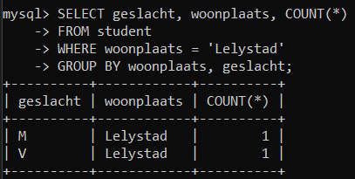

OPDRACHT 6.7

OPDRACHT 6.8

OPDRACHT 6.9

OPDRACHT 6.10

OPDRACHT 6.11

